

**COMSATS University Islamabad,**

**Sahiwal Campus.**

**Photography Market Place**

***By***

**Muhammad Azeem Anjum CIIT/SP16-BCS-033/SWL**

**Muhammad Zain Haider CIIT/SP16-BCS-046/SWL**

***Supervisor***

***Muhammad Usman Nasir***

***Bachelor of Science in Computer Science (2016-2020)***

The candidate confirms that the work submitted is their own and appropriate credit has been given where reference has been made to the work of other



**COMSATS University Islamabad,**

**Sahiwal Campus.**

**Photography Market Place**

**A Project Presented To**

**COMSATS Institute of Information Technology, Islamabad**

**In partial fulfillment**

**of the requirement for the degree of**

***Bachelor of Science in Computer Science (2016-2020)***

***By***

**Muhammad Azeem Anjum CIIT/SP16-BCS-033/SWL**

**Muhammad Zain Haider CIIT/SP16-BCS-046/SWL**

**DECLARATION**

We hereby declare that this system, neither whole nor as a part has been copied out from any source. It is further declared that we have developed this website and accompanied report entirely on the basis of our personal efforts. If any part of this project is proved to be copied out from any source or found to be reproduction of some other. We will stand by the consequences. No Portion of the work presented has been submitted of any application for any other degree or qualification of this or any other university or institute of learning.

Muhammad Azeem Anjum Muhammad Zain Haider

**CERTIFICATE OF APPROVAL**

It is to certify that the final year project of BS(CS) “Photography Market Place” was developed by Muhammad Azeem Anjum (CIIT/SP16-BCS-033/SWL) and Muhammad Zain Haider (CIIT/SP16-BCS-046/SWL) under the supervision of “Mr. Muhammad Usman Nasir” and co supervisor “Mr. Muhammad Amir” and that in their opinion; it is fully adequate, in scope and quality for the degree of Bachelors of Science in Computer Sciences.

**Supervisor**

**Mr. Muhammad Usman Nasir**

**External Examiner**

**Dr. Muhammad Munwar Iqbal**

**Head of Department (Computer Sciences)**

**Dr. Javed Ferzund**

**Executive Summary**

We learn a lot of skills during the development and testing of this project. Front end development with responsive designs, designing the relevant graphic works and will also learn about the selection, understanding and making the most suitable logo for our application. Programming languages are most important for the development of project so we will learn about the basic concepts of languages that will be used in the development of the project and after that we will maintain the system according to the market/field requirements. Data storage is the most important task nowadays, so we will use SQL queries to get data from the backend users and store it in our database. It is very important to stay alert of user’s data to analyze and monetarize the working status of our clients and users so we will use database to complete such tasks.

Most of our application runs on the windows platforms that handle both static and dynamic websites and by using these we will also prefer this website to run on the window operating system. Furthermore, the system specification must be suitable for this website to run by any administrator and visit by users. For this website system need few spaces of RAMS, Hardware and CPU to support this type of website easily. This website will work on every operating system came after window 7 and can be supported by any type and versions of browsers installed in your operating system.

This application is targeting the local users and clients of the Pakistan so this system only accessible with in our country. And all the transections and work must be according to the profiles of the users, the most experienced the person is the more work he will get.

After completion of the tasks given from client to user the final transactions of the project must be deliver in PKR by using Jazz Cash / Easy Paisa direct to the user account. No 3rd party or transaction method is used in used in this project to deliver money to user.

For the getting of work by the clients the user must have their related work to upload on their profiles and make their profile advance and concise related to their field of work.

**Acknowledgement**

All praise is to Almighty Allah who bestowed upon us a minute portion of His boundless knowledge by virtue of which we were able to accomplish this challenging task.

We are greatly indebted to our project supervisor “Mr. Muhammad Usman Nasir” and our Co-Supervisor “Mr. Muhammad Amir”, without their personal supervision, advice and valuable guidance, completion of this project would have been doubtful. We are deeply indebted to them for their encouragement and continual help during this work.

And we are also thankful to our parents and family and friends who have been a constant source of encouragement for us and brought us the values of honesty & hard work.

Muhammad Azeem Anjum Muhammad Zain Haider

**Abbreviation**

|  |  |
| --- | --- |
| **PMP** | Photography Market Place |
| **UCD** | Use Case Diagram |
| **XAMPP** | Cross-Platform Apache MySQL PHP Perl |
| **DFD** | Data Flow Diagram |
| **API** | Application Programming Interface |
| **SD** | Sequence Diagram |
| **HTML** | Hypertext Markup Language |
| **CSS** | Cascading Style Sheets |

**Table of Contents**

1. Introduction 1

1.1 Brief 1

1.2 Relevance to Course Modules 2

1.2.1 Project Background 2

1.3 Literature Review 3

1.4 Analysis from Literature Review 3

1.5 Methodology and Software Lifecycle for This Project 3

1.5.1 Incremental Model 4

1.5.2 Rationale behind Selected Methodology 4

2. Problem Definition 5

2.1 Problem Statement 5

2.2 Deliverables and Development Requirements 5

2.3 Current System 6

3. Requirement Analysis 7

3.1 Use Cases Diagram(s) 7

3.2 Detailed Use Case 7

3.3 Functional Requirements 10

3.3.1 USER MODULE 10

3.3.2 CLIENT MODULE 10

3.3.3 ADMIN MODULE 11

3.4 Non-Functional Requirements 11

4. Design and Architecture 12

4.1 System Architecture 13

4.2 Data Representation 13

4.3 Process Flow/Representation 14

4.4 Design Models 15

4.4.1 Sequence Diagram 15

4.4.2 Class Diagram 15

4.4.3 Data Flow Diagram 16

5. Algorithm & Implementation 17

5.1 External APIs 18

6. Testing and Evaluation 18

6.1 Manual Testing 18

6.1.1 System testing 18

6.1.2 Unit Testing 19

6.1.3 Functional Testing 20

6.1.4 Integration Testing 21

6.2 Automated Testing 21

7. Conclusion and Future Work 22

7.1 Conclusion 22

7.2 Future Work 22

8. References 23

**List of Figures**

Figure 1: Incremental Model Diagram 4

Figure 2: Home Page 6

Figure 3: Use Case PMP 7

Figure 4: Architecture design using Model View Controller 12

Figure 5: Architecture design System 13

Figure 6: Data Representation 13

Figure 7: Flow Chart 14

Figure 8: Sequence Diagram 15

Figure 9: Class Diagram 15

Figure 10: DFD Level 0 16

Figure 11: DFD Level 1 16

**List of Tables**

Table 1: Related System Analysis 3

Table 2: Detailed Use Case 9

Table 3: Admin Module 11

Table 4: External APIs 18

Table 5: Unit Test 1 19

Table 6: Unit Test 2 19

Table 7: Functional Test 20

Table 8: Integration Test 21

# 1. Introduction

Photography websites (Epstein, 2018) are spread over the whole country. They provide the basic facilities and functionalities to photographers which includes their portfolio galleries and their e-stores to sell their products like photographs, Photoshop actions, presets and plugins. Freelancer websites are also providing a lot of freelance work for photographers and clients in foreign countries but are not doing well in our country. Similarly, online photography competitions are also a main trend nowadays. These systems lack multiple facilities for their users and are a waste of time and money for those who need all these facilities like, the photographers who need to build their own portfolio website have to build a new system from scratch on which they can display their portfolio gallery and sell their products. This process is very time consuming and waste of money for buying domains, hosting and paying to the developers. That’s the point where it is needed to build a website which include all these features and merging them into a single website so users do not have to waste their time by going onto different websites to perform their tasks or pay heavily for building their profiles. We are providing a single platform which performs almost every basic task related to photography which all the photographers and people interested in this field are looking for, so they can get all that facilities which they need under a single platform (Lee, 2018).

## 1.1 Brief

Many different websites have different services running separately not any website have all services and we are offering all services in one platform. This system will cover all remaining clauses, requirements, drawbacks, limitations and disadvantages. For example, if any user will sell their services and client or user will buy those services and clients can directly hire service providers for their events. User will upload their portfolio on their profiles and both user and client will review their profiles and can buy any service or can hire for custom service. By implementing this system will help our local service providers to do their work easily and freely at their homes without investing anything.

This system targets specific audience and only related to photographers and photography. This system will provide opportunities to photographers and clients. Photographers can earn by selling their services and clients can hire photographers and buy their services. This system provides two types of accounts one is for freelancers (photographers who will sell services) and other for clients (who will buy those services). There will be two types of freelancer account one is free account and second is premium.

In free account users will have limited range of proposals for custom services (clients will post custom services) and in paid account user can check other user’s proposal’s price and can send 20% extra proposals by paying some amount. This system will not allow to share any personal information to any user and all the transactions are being processed through this system. If any user violates any TOS (term of service) then the user will not be able to access that account again.

## 1.2 Relevance to Course Modules

We have tried to make a website with the help of our relevant courses of our degree in Bachelors in Computer Science. First we have tried to approach our requirements then we gather the area in which our project works then we analyze the model which fulfill the requirement of our project because all these things are being taught to us in Software Engineering 1 and 2. Then we are working on interface of our website which fulfill the need of our subject Human Computer Interface. Then after this we start our development in Web because in web we have studied HTML and CSS and then we do development in Xampp server and in PHP. Then we learn about the Copyright and about References in Professional Practices in IT for our safety and security.

### 1.2.1 Project Background

Many people in Pakistan spend a lot of money for buying Photoshop actions, presets, plugins and tutorials from websites in abroad because of lack of such platforms in Pakistan, clients and photographers both are not getting any sort of benefit as well as satisfaction. We want our people to invest in our country on our people instead of other countries and their people.

In Pakistan we don’t have such single platform which provides photographers a chance to get work, also the clients to hire a photographer from home and buy presets and photos. Many photographers of Pakistan with best skills aren’t getting any work just because of the lack of such resources so this system tries to help them by building up a single website. There is not a single combined system for such purpose till now but separately they’re developed. By developing this system some skills will be polished like PHP, Ajax, JQuery, Bootstrap, Xampp.

## 1.3 Literature Review

|  |  |
| --- | --- |
| **System Name** | **Weakness** |
| Freelancer(Freelancer, 2019) | Weaknesses may include limited features, low quality functionality and processes. |
| Upwork(Upwork, 2019) | Approve accounts of professional users only after analyzing their profile. |
| ViewBug(ViewBug, 2019) | No contact between user and client, moreover no reviews about their work. |
| Sellfy ("symufa," 2019) | Only for users to sell their products not for hiring the service providers. |

Table 1: Related System Analysis

## 1.4 Analysis from Literature Review

* This system charge Service fee when project will be complete
* This system will approve both new and professional users
* This system will be able to get reviews of work and let the most highly rated work on top
* This system will also allow the user and client to propose their work and also allow the client to hire the service provider temporarily or permanently

## 1.5 Methodology and Software Lifecycle for This Project

This system will be developed into many development ways but most authentic and suitable life cycle is Incremental model.

### 1.5.1 Incremental Model

This system will be developed in module wise, first it has to define its users and then their integration with other users as well as with admin. First it has to developed simple users to check whatever the requirements of our project proposal are meeting with this project or not then we will develop the client side module to integrate the work to hire and purchase demanded work. And transactional module will integrate after these two modules to get paid by client and get payments from client side users. At the end admin module will be developed to monitories and check the work of users.

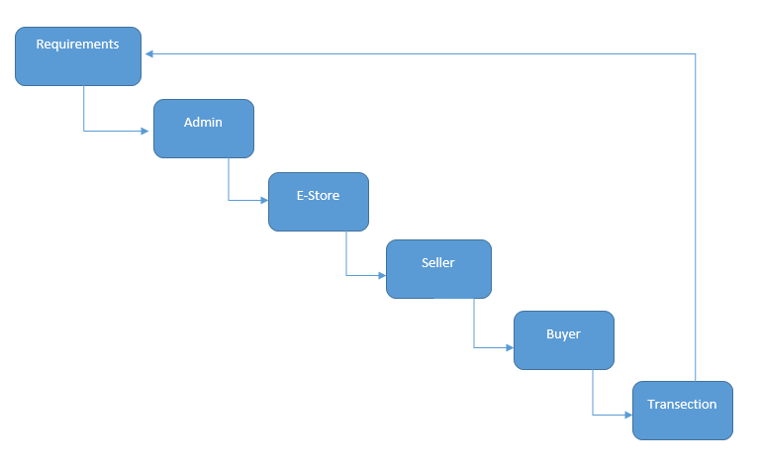

Figure 1: Incremental Model Diagram

### 1.5.2 Rationale behind Selected Methodology

System support one by one step development for our users to communicate, buy and sell products so incremental model is the suitable model for our project. In first phase we developed the login and signup module and then we create user profile for uploading all of it content related to his work.

Another phase covers the other user’s profile to see and buy the products of seller and vice versa. And at the end the final module of payment method is integrated with project to get payment by clients of our products.

# 2. Problem Definition

Discussing the precise problem to be solved. It extends to include the outcome.

## 2.1 Problem Statement

If we look back in past, then earning online money isn’t easy task but nowadays it is very easy to earn online at your place within few hours but everything has its advantages and disadvantages. Current freelancing websites providing some modules and all websites differ in some functionalities so this project will customize and override all the possible clauses, disadvantages and remaining requirements of users. Many people in Pakistan also spend a lot of money for buying Photoshop actions, presets, plugins and tutorials from websites in abroad because of lack of such platforms in Pakistan, clients and photographers both are not getting any sort of benefit as well as satisfaction. We want our people to invest in our country on our people instead of other countries and their people.

In Pakistan we don’t have such single platform which provides photographers a chance to get work and also the clients to hire a photographer from home. Many photographers of Pakistan with best skills aren’t getting any work just because of the lack of such resources so this system tries to help them by building up a single website. There is not a single combined system for such purpose till now but separately they’re developed. By developing this system some skills will be polished like PHP, Ajax, JQuery, Bootstrap, Xampp.

## 2.2 Deliverables and Development Requirements

This system will have following modules:

* Module 1: User module
* Module 2: Client module
* Module 3: Admin Server

All modules will be online web based application that can be on mobile.

## 2.3 Current System

This system will be used by clients and the buyers including the photographers. The scope of this system is restricted and it can be used with in our country only, starting from best photos to purchase and it also includes filters for the photographers to purchase to improve the quality of their photos within whole country. This will be a complete end to end system that will be designed in a very easy to use interface that can be used by everyone easily. After completion this will be uploaded to the host with a unique domain name in order to facilitate our local freelancers and photographers to earn within country with easy money transaction procedure. This system provides the best facilities and services to every photographer and freelancer in a certain environment which includes filter and photos purchasing. Basic e-commerce services, Maintenance of user’s accounts and data to be sell, Money transaction procedures are the services of the product. There should be a check and balance for the common facilities as well as it is also their responsibility to keep their earning environment clean to be facilitated. So that's why we thought of making a system that could help a lot than local dealers and sellers in performing their tasks way better than before. This system will have following module: User module, Admin module, Client Side. All modules will be responsive so that can easily be accessed by mobiles too.

The following figure is current view of system.

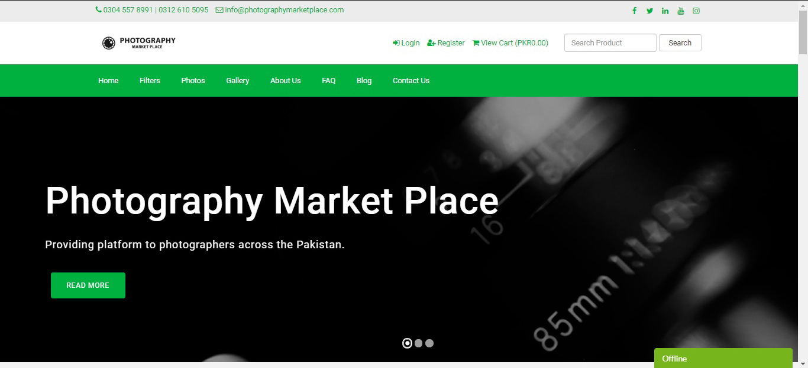

Figure 2: Home Page

# 3. Requirement Analysis

## 3.1 Use Cases Diagram(s)

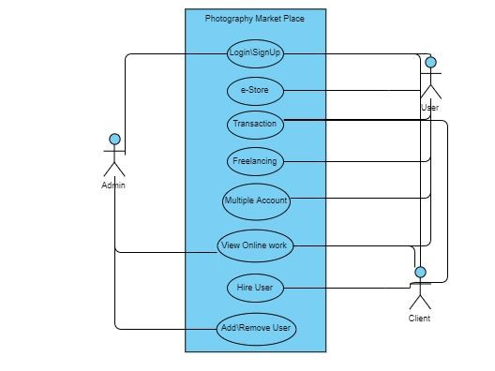

Figure 3: Use Case PMP

## 3.2 Detailed Use Case

The table below indicate a comprehensive use case template filled in with an example drawn from the **PHOTOGRAPHY MARKET PLACE**.

|  |  |
| --- | --- |
| **Use Case ID:** | PMP-1 |
| **Use Case Name:** | **Photography Market Place** |
| **Actors:** | Primary Actor :User, Client Secondary Actors: Admin |
| **Description:** | A user accesses the photography market place for Photography from the user panel to get facilitated from all services that we are providing them. They can buy filters and work of others photographers too.  A client will be responsible for viewing the work and hiring the best photographers from the main page and can also view the portfolio of user’s work.  An admin is responsible for all maintenance and overlook of the work done by users and clients |
| **Trigger:** | A User indicates that they want to upload their work and get work and money after any work completion about any service they are facilitating by Photography Market Place.  A Client indicates that he is responsible to view and hire the best photographers.  Admin is responsible for all maintenance and overlook of work. |
| **Preconditions:** | PRE-1. Both User and Client are logged into Photography Market Place to use it.  PRE-2. Both Client and User must be registered for proper usage of this application and transactions of money into accounts to work done from both sides.  PRE-3. Admin must have access to all accounts to check their work and duty. |
| **Post conditions:** | POST-1 Portfolio is uploaded in Photographer’s timeline with a status of “Work Status.”  POST-2 Status of available photographers and their work is updated to reflect Photographers in this application.  POST-3 Remaining work and photographers and their services list is updated. |
| **Normal Flow:** | User has to login for profile and uploading their works by their username and password.  Client asks to users to show the relevant work and portfolio to get work from services or client can just buy his pictures.  Photography Market Place displays menu of available services and the daily user’s work of photography to client.  User can select one or more services for uploading the work.  User will see “Uploaded” message after uploading the portfolio. |
| **Alternative Flows:** | Upload multiple identical portfolio and work.  User can upload portfolio and work for more than one service.  User can go back to condition one for uploading more portfolio and work after uploading one.  After Viewing or client purchasing all possible work and portfolio both user and client can logout. |
| **Exceptions:** | Photography Market Place updates the Client about most of uploaded work that are uploaded by the users and client can hire or purchase user’s product and assign the task to photographers to check the proficiency of photographers by completing the task. |
| **Business Rules:** | BR-1 Delivery time of money transactions are 15 working days, beginning on each quarter hour.  BR-2 Deliveries of photos and filters must be completed within 30 minutes. |
| **Assumptions:** | Assume that more than 10 users will be hired by same client then  A record of employees on daily Basis then admin must take notice of not working the employees. |

Table 2: Detailed Use Case

## 3.3 Functional Requirements

This system will have following modules:

* Module 1: User module
* Module 2: Client module
* Module 3: Admin Server

All modules will be online web based application that can be on mobile.

### 3.3.1 USER MODULE

1. User will login using his own profile
2. Can check the work of clients and other user’s work.
3. Can see the contact details of the client
4. Can get money from client
5. Can purchase filters

### 3.3.2 CLIENT MODULE

This module will be used by client only.

1. Login using his secret timeline
2. Will check the work in the following categories under his area
   1. Completed work by photographers
   2. Under process work
   3. New portfolio
3. Will check the new portfolio uploaded by any new user and can hire the respective worker
4. Once the photographer has completed the task, the client will mark that as completed and that work will go in the completed section

### 3.3.3 ADMIN MODULE

This module will be used by Admin only.

|  |  |
| --- | --- |
| **Identifier** | Admin |
| **Title** | Monitoring Work |
| **Requirement** | Admin must analysis the overall work by the clients and users to keep balance between both and can fire or block anyone if they are not following the rules of the website |
| **Source** | From both client and user side |
| **Rationale** | To provide and facilitate all the best product in local country without any bug |
| **Business Rule (if required)** | Users and clients must need their transactions method to get money |
| **Dependencies** | Both client and users |
| **Priority** | High |

Table 3: Admin Module

## 3.4 Non-Functional Requirements

Non Functional Requirements are the requirements that specify criteria that can be used to judge the operation of system. Those constraints under which system will be operated is called non-functional requirements. For example, language run time environment, operating environment performance requirements, usability requirements etc. These are all those requirements whose are not belonged to functional requirements but they affect overall on the system. We can say some extra conditions requirements that are not included in the use cases. These are usually called non-functional requirements.

# 4. Design and Architecture

The structure of the system explains its core components, their relationships, and how they deal with each other. Software architecture and design includes several factors such as business strategy, quality attributes, human dynamics, design and IT environment. In Architecture, nonfunctional decisions are cast and separated by the functional requirements. In Design, functional requirements are accomplished. Admin module is very important. It is a major module in this admin have all rights to manage system, sales, client members, message, feedback. Anyone can visit, anyone can visit the main page related to system and can get information and know about our system that how to use to system and how anyone can get their self-registered. A combination of the modules makes up the system. We can use flowcharts to represent and illustrate the architecture.

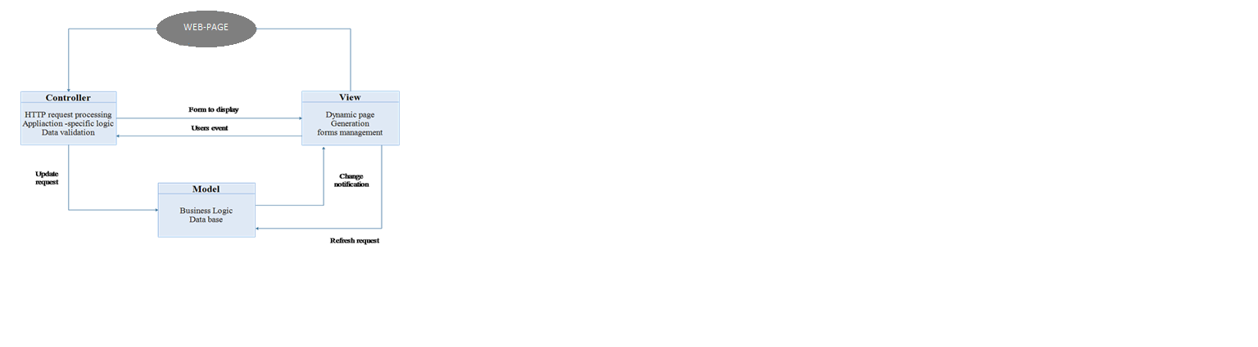

Figure 4: Architecture design using Model View Controller

## 4.1 System Architecture

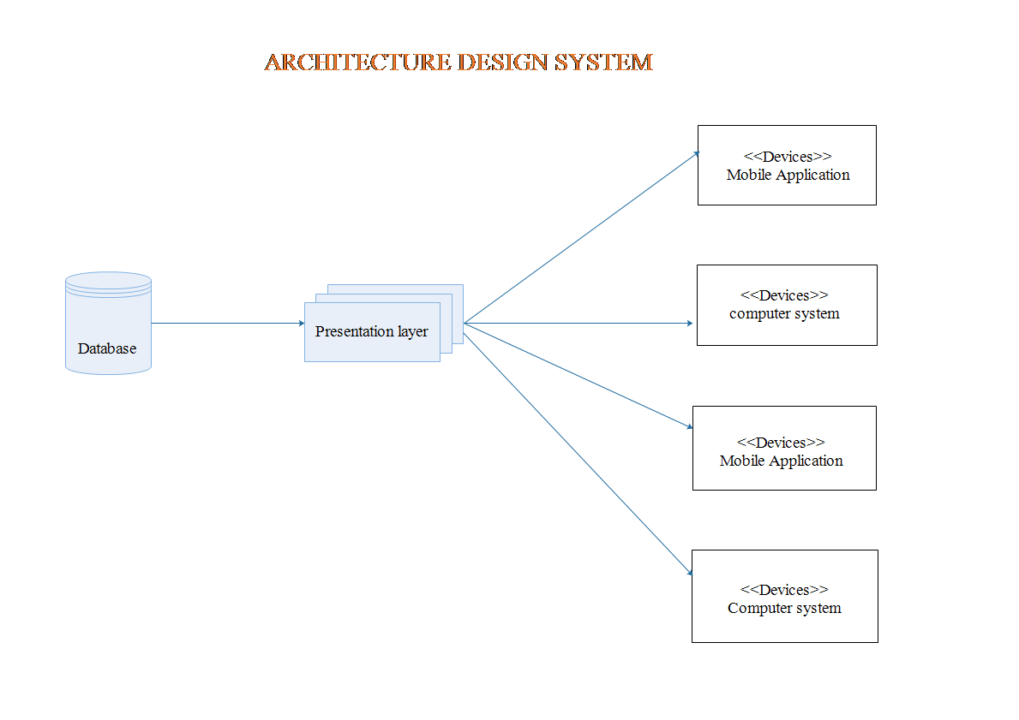

Figure 5: Architecture design System

## 4.2 Data Representation

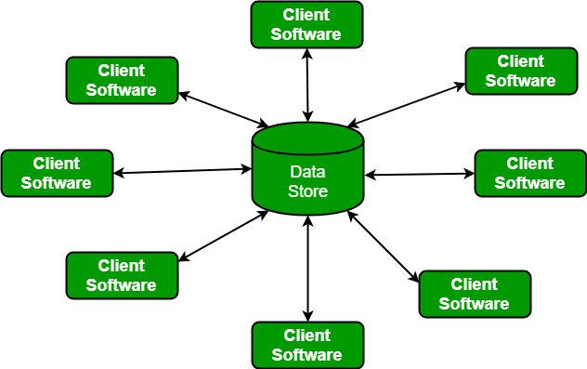

Figure 6: Data Representation

## 4.3 Process Flow/Representation

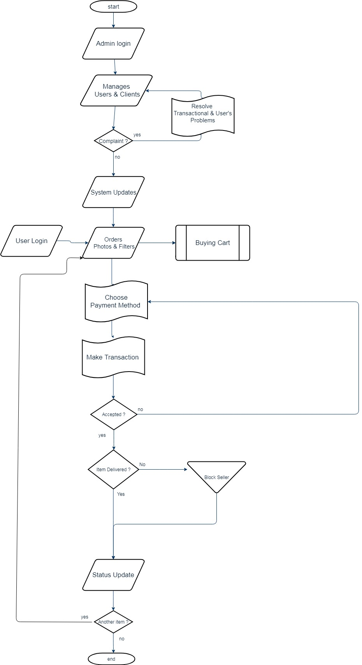

Figure 7: Flow Chart

## 4.4 Design Models

### 4.4.1 Sequence Diagram

This image shows that how system will work, tasks after task with sequence wise. It gives the complete description the working of our system.

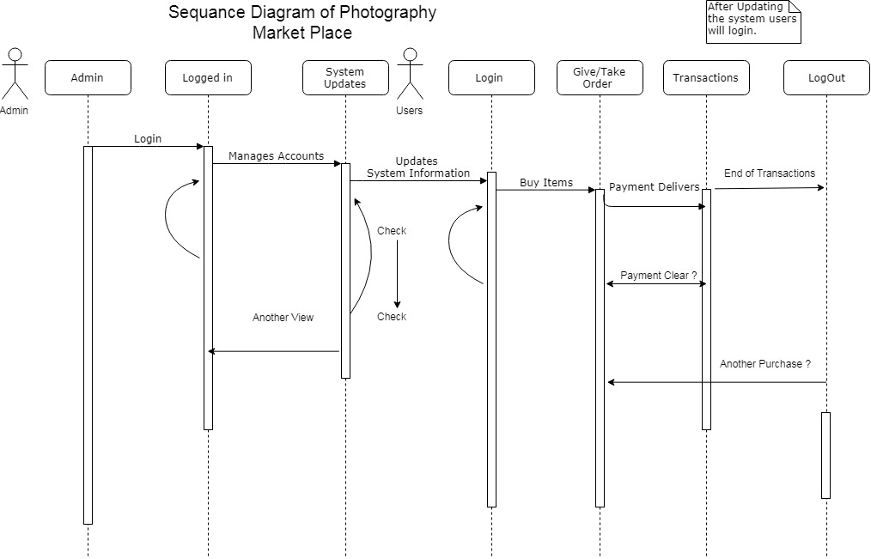

Figure 8: Sequence Diagram

### 4.4.2 Class Diagram

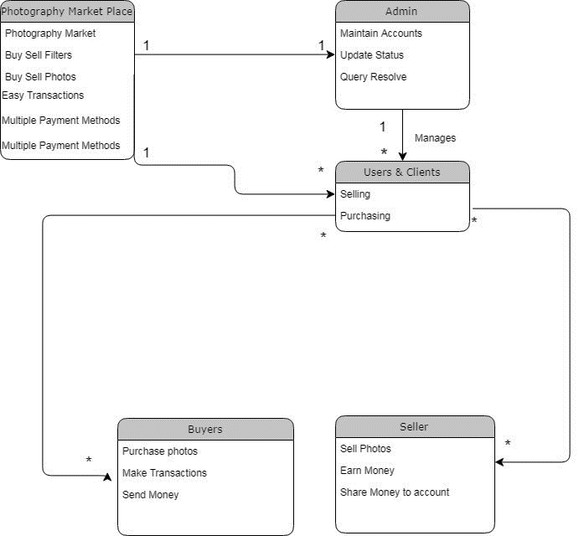

Figure 9: Class Diagram

### 4.4.3 Data Flow Diagram

This diagram represents the flow of data or process of the system. It gives complete information about the outputs and generated after providing user’s inputs of each module and process itself.

**LEVEL 0**

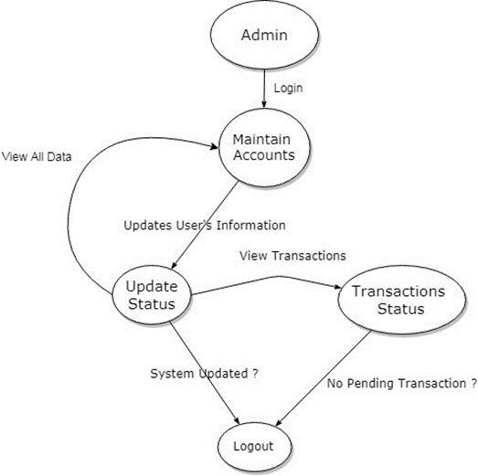

Figure 10: DFD Level 0

**LEVEL 1**

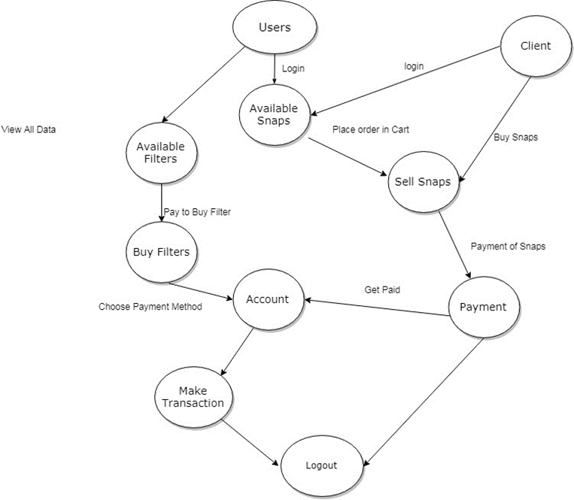

Figure 11: DFD Level 1

# 5. Algorithm & Implementation

* We don’t have to implement this application within any organization, educational institutes, or within corporation, you just need to host it to give facilitates the photographers so they can easily earn within their local places
* User must login to get facilitate
* Select the photos well likely to get paid
* Write down the details of photos
* Submit the item to Cart
* Upon transaction of any photo or preset, he will be given the transaction number from the server
* Firstly, we must give an access to any administrator for administrator’s role
* He can register all the users or client of this system
* Any member can access this application with high speed internet connection and with his/her email address and password
* Members can buy, check status of transaction, give feedback and modify his profile
* Admin can update user’s status whenever someone gave a complaint against them
* Administrator can update add and delete

## 5.1 External APIs

APIs used are in the following table

|  |  |  |  |
| --- | --- | --- | --- |
| **API Name** | **Description** | **Purpose** | **List down the function/class**  **name in which it is used** |
| JazzCash | JazzCash enables quick and easy integration for its merchants with our next generation payment gateway. Merchants can Self-Register, Test transactions and Go-Live to start accepting payments. JazzCash offers a variety of integration modes depending on merchant’s functionality. | Through its innovative services and products, Jazz is set to bring about a digital revolution that will enable and transform societies towards a more progressive Pakistan. | • Card Payment  • Mobile Acc.  • Direct Debit |

Table 4: External APIs

# 6. Testing and Evaluation

This chapter include the following sections.

## 6.1 Manual Testing

### 6.1.1 System testing

Once the system has been successfully developed, testing has to be performed to ensure that the system working as intended. This is also to check that the system meets the requirements stated earlier. Besides that, system testing will help in finding the errors that may be hidden from the user. There are few types of testing which includes the unit testing, functional testing and integration testing. The testing must be completed before it is being deploy for user to use.

### 6.1.2 Unit Testing

**Unit Test 1:** CLIENT Login/Signup

**Testing Objective:** To ensure the login/signup form is working correctly

|  |  |  |  |  |
| --- | --- | --- | --- | --- |
| **No.** | **Test Case** | **Attributes & Values** | **Expected Result** | **Result** |
| **01** | User Authentication | Email ID/Password | Member | Pass |
| **02** | Sign Up | Full Name  Email Address  Phone Number  Address | Register | Pass |

Table 5: Unit Test 1

**Unit Test 2:** Edit Profile Information

**Testing Objective:** To ensure the edit profile form is working correctly

|  |  |  |  |  |
| --- | --- | --- | --- | --- |
| **No.** | **Test Case** | **Attributes & Values** | **Expected Result** | **Result** |
| **01** | Update Profile | Full Name  Phone Number  Address | Update | Pass |
| **02** | Update Password | New Password  Retype New Password | Update | Pass |

Table 6: Unit Test 2

### 6.1.3 Functional Testing

The functional testing will take place after the unit testing. In this functional testing, the functionality of each of the module is tested. This is to ensure that the system produced meets the specifications and requirements.

**Functional Test:** Login with Admin

**Objective:** To ensure that the correct page with the correct navigation bar is loaded.

|  |  |  |  |  |
| --- | --- | --- | --- | --- |
| **No.** | **Test Case** | **Attributes & Values** | **Expected Result** | **Result** |
| **01** | Login as Admin | Username: [admin@gmail.com](mailto:admin@gmail.com)  Password: 1234 | Main page of Photography Market Place is loaded with the Main Navigation Bar | Pass |

Table 7: Functional Test

### 6.1.4 Integration Testing

|  |  |  |  |  |
| --- | --- | --- | --- | --- |
| **No.** | **Test Case** | **Attributes & Values** | **Expected Result** | **Result** |
| **01** | Login as Admin | Username: [admin@gmail.com](mailto:admin@gmail.com)  Password: 1234 | Login Successfully and the main page of Photography Market Place is loaded with the main Navigation Bar | Pass |
| **02** | Upload Product | Top Level Category  Mid Level Category  End Level Category  Product Name  Price  File  Description | Product successfully added, return to products page and products are updated | Pass |

Table 8: Integration Test

## 6.2 Automated Testing

Automatic testing tools are not available for free and for using them a lot of professional experience is required to test the application whatever it is working correctly or not. Hence we used manual testing.

# 7. Conclusion and Future Work

## 7.1 Conclusion

The developed application has interactive interface design with awesome color scheme that has no effect on user’s eyes, efficient in use and less time consuming. The system responds in less time as compare to other conventional websites. This system will override all the relevant sites in developing, payments transections, e-Store and freelancing system in Pakistan. It will be a wonderful and learning experience for us while working on this project. Due to this project we experienced that how a professional software is designed, developed and tested one after another after requirements gathering and analyzing. The system will help us to reduce our time complexity and cost. The project has its future work which will be developed and designed after completion of this module.

## 7.2 Future Work

For the beginners it is not possible to solve all problems that we are facing these days in Pakistan so we have some points that we will cover in future to launch this application in real life.

Some of future work is given below

* Hiring photographers for events
* Project Bidding
* Photography Competitions
* Photo Editor

# 8. References

Epstein, N. (2018). *Susan Sontag's On Photography*: Macat Library.

Freelancer. (2019). Freelancer Retrieved from https://www.freelancer.com

Lee, C.-k. (2018). Time-lapse photography system and method: US Patent App. 15/622,975.

symufa. (2019, 03 26). *sellfy*. Retrieved from <https://sellfy.com>

Upwork. (2019). Upwork. Retrieved from https://www.upwork.com

ViewBug. (2019). Retrieved from https://www.viewbug.com

500px. (2019). Retrieved from https://www.500px.com